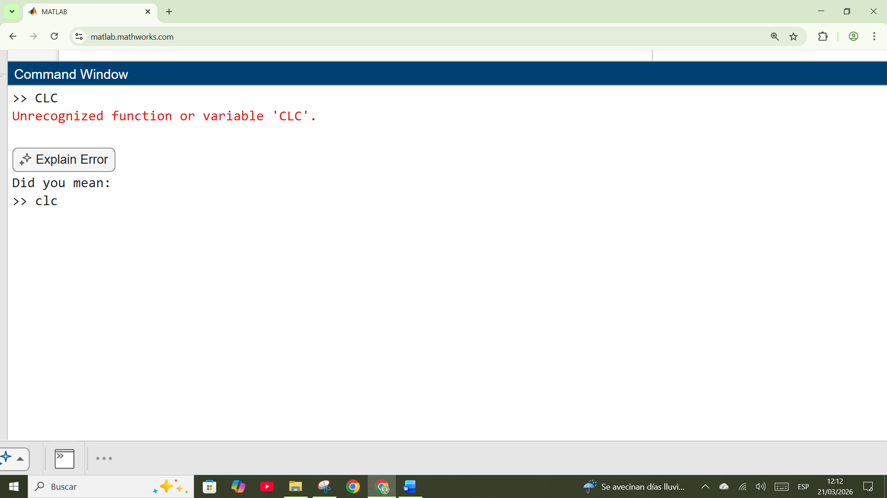
BORRAR PANTALLA EN MINUSCULA
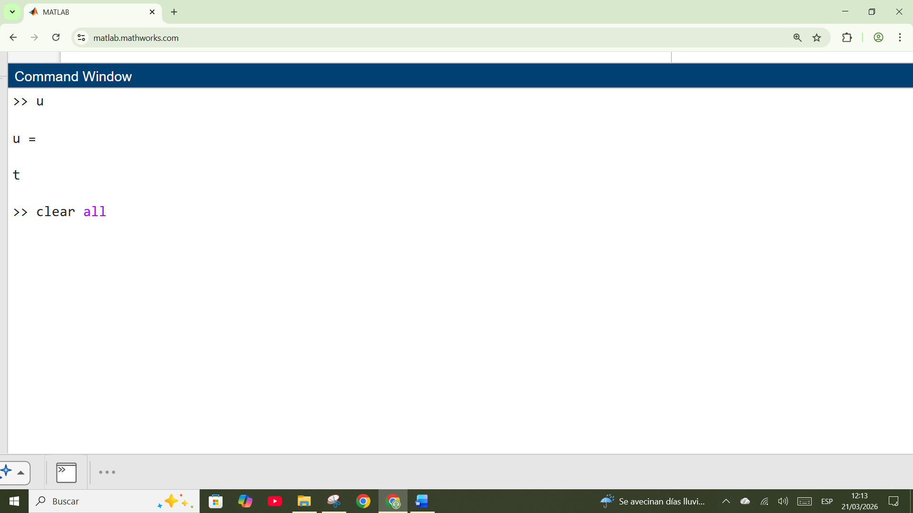
Borrar todas las variables

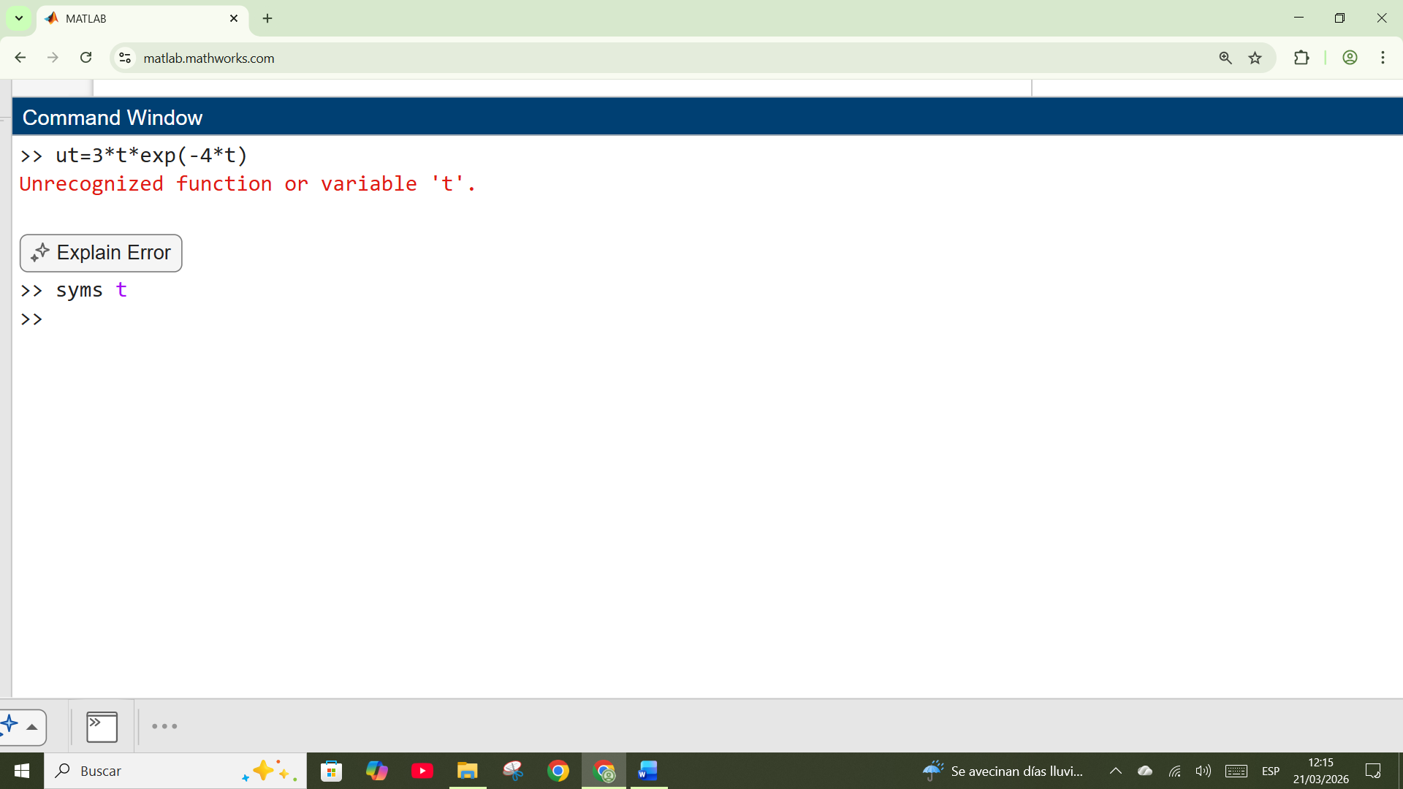
Declarar variables
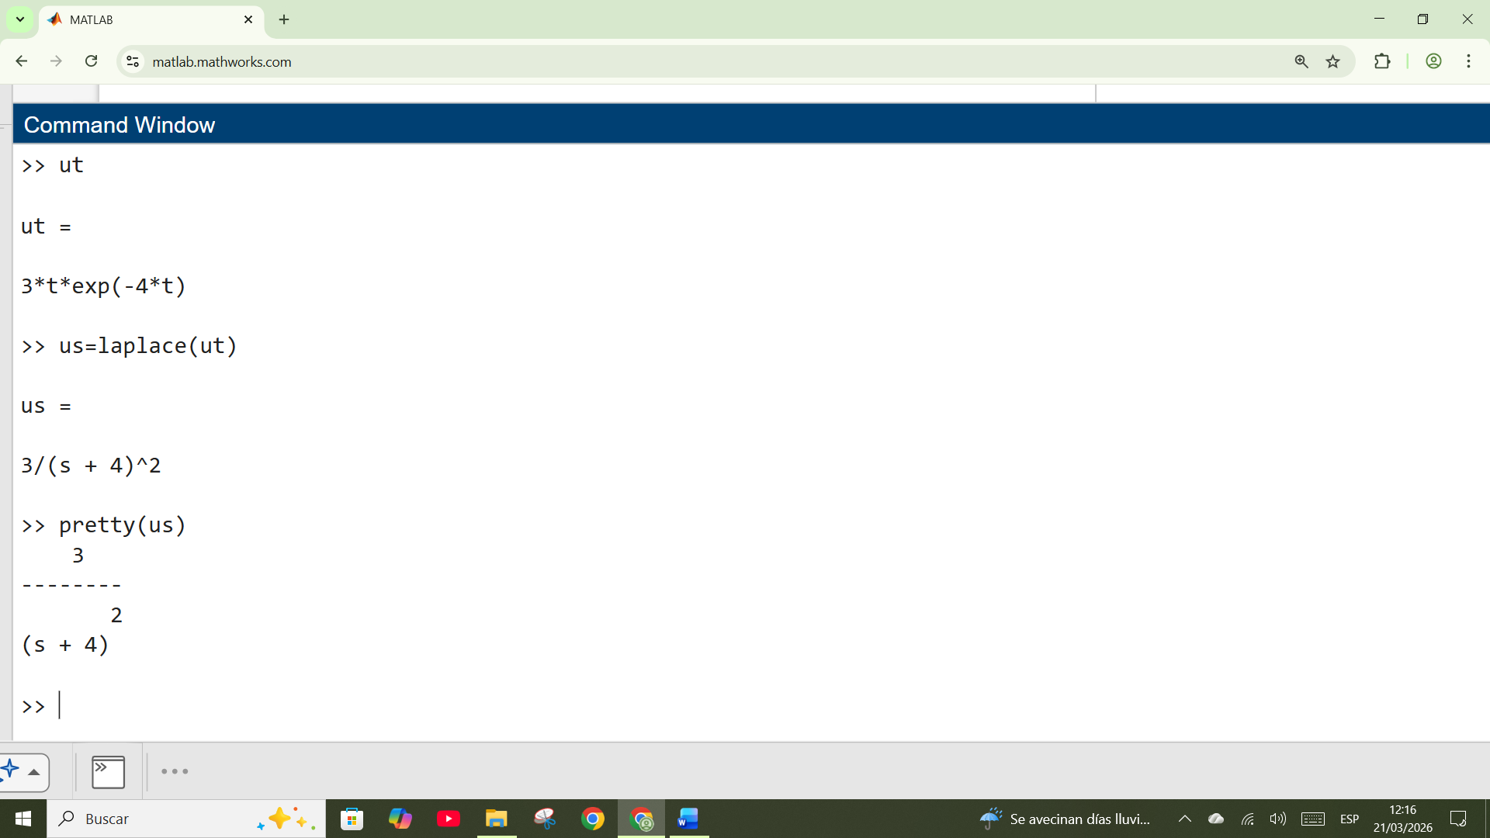
Definimos t como variable
Creamos u(t)
Y con laplace(u(t)) creamos a U(s)

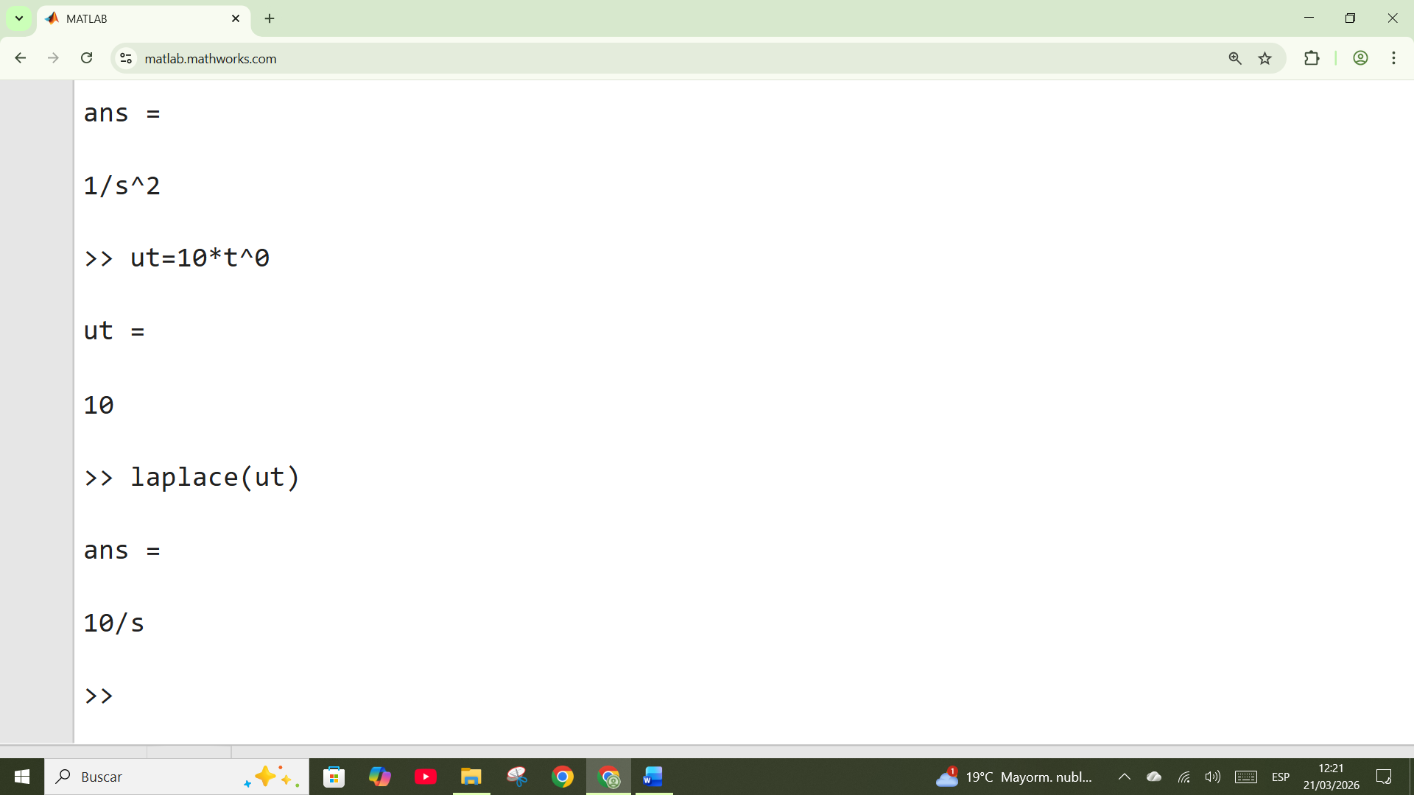
La monto Matlab debe definir aunque sea t^0 para que Matlab entienda el Laplace

>> ut=10
ut =
10

>> us=laplace(ut)
Incorrect number or types of inputs or outputs for function laplace.
>> us
us =
3/(s + 4)^2
>> us=laplace(ut)
Incorrect number or types of inputs or outputs for function laplace.
>> clear us
>> us=laplace(ut)
Incorrect number or types of inputs or outputs for function laplace.
>> r=10
r =
10

>> laplace(r)
Incorrect number or types of inputs or outputs for function laplace.
>> clear all
>> syms s
>> syms t
>> ut=10
ut =
10

>> us=laplace(ut)
Incorrect number or types of inputs or outputs for function laplace.
>> ut=t
ut =
t
>> laplace(ut)
ans =
1/s^2
>> ut=10*t^0
ut =
10
>> laplace(ut)
ans =
10/s
>> us=laplace(ut)
us =
10/s
>> gs=16/(s^2+2*s+16)
gs =
16/(s^2 + 2*s + 16)
>> pretty(gs)
16
-------------
2
s + 2 s + 16

>> ys=us*gs
ys =
160/(s*(s^2 + 2*s + 16))
>> pretty(ys)
160
-----------------
2
s (s + 2 s + 16)

>> ilaplace(ys)
ans =
10 - 10*exp(-t)*(cos(15^(1/2)*t) + (15^(1/2)*sin(15^(1/2)*t))/15)
>> pretty(ilaplace(ys))
/ sqrt(15) sin(sqrt(15) t) \
10 - exp(-t) | cos(sqrt(15) t) + ------------------------ | 10
\ 15 /

>> yt=ilaplace(ys)
yt =
10 - 10*exp(-t)*(cos(15^(1/2)*t) + (15^(1/2)*sin(15^(1/2)*t))/15)
>> yt=ilaplace(ys)

ACA CREAMOS U(t) luego hallamos U(s) luego creamos G(s) luego hicimos Y(s)=U(s).G(s)

Finalmente Y(t)=ilaplace(Y(s))

XXXXXXXXXXXXXXXXXX

Instrucción R,P,K = residue

>> num=[160];
>> den=[1 2 16 0];
>> [r,p,k]=(num,den)
[r,p,k]=(num,den)
↑
Error: Unexpected ',' in parentheses. When creating a matrix, use square brackets [].
>> [r,p,k] = residue(num,den)
r =
-5.0000 + 1.2910i
-5.0000 - 1.2910i
10.0000 + 0.0000i
p =
-1.0000 + 3.8730i
-1.0000 - 3.8730i
0.0000 + 0.0000i
k =
[]

Generar función de transferencia para graficar
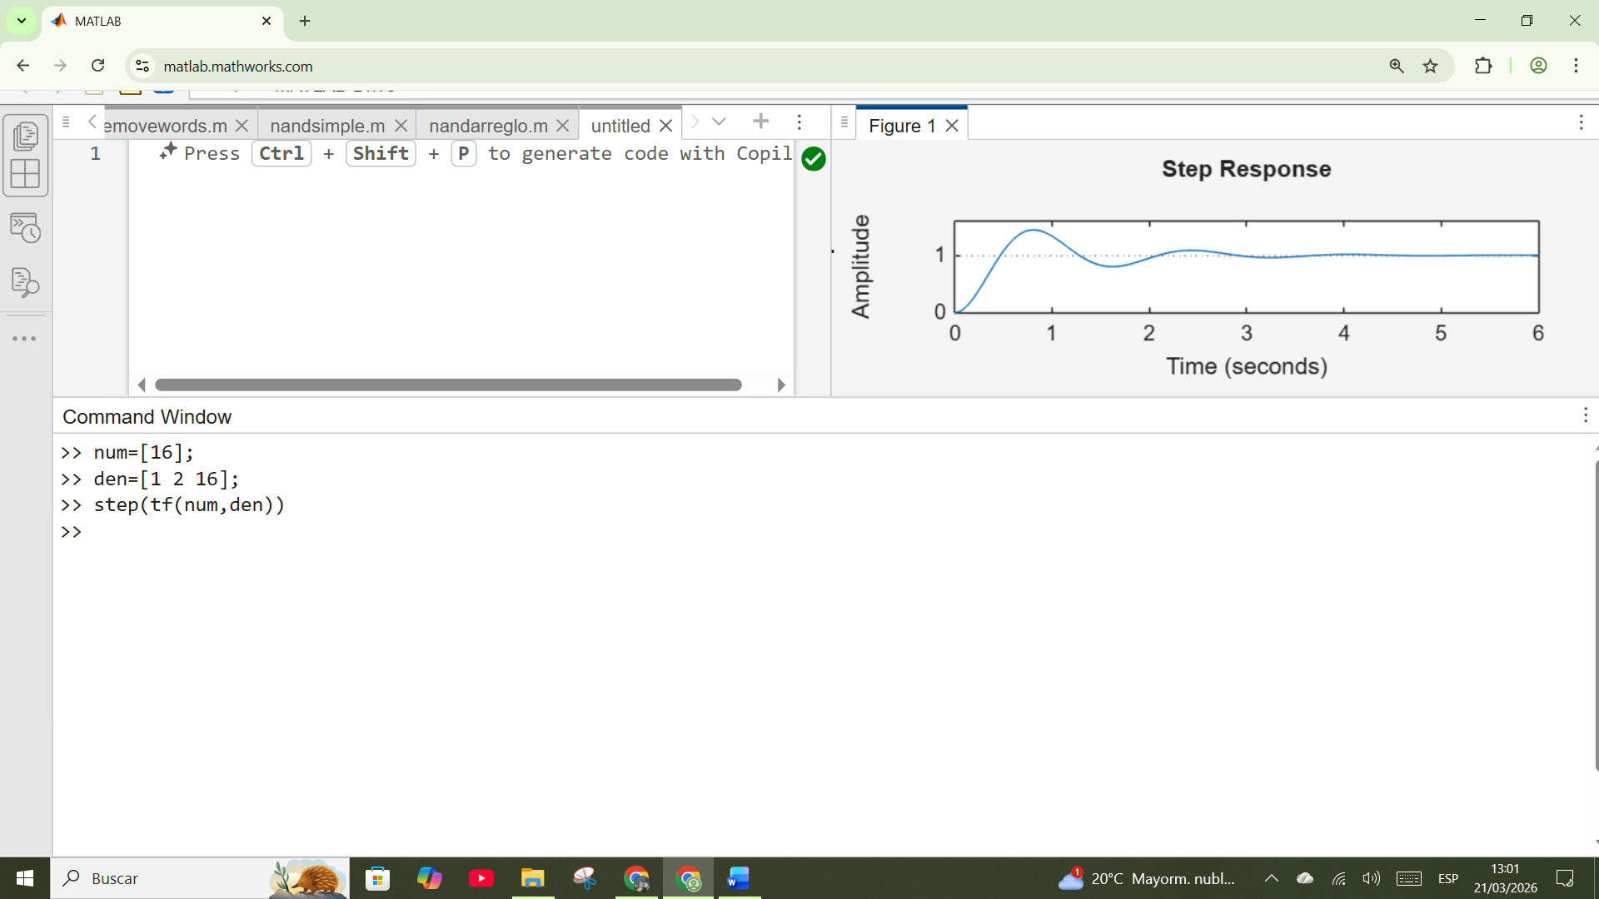

Para graficar con instrucción al escalon

